The entity-relationship model

First understand the structure of data, process refined along the years. A good way to design a database is to proceed in two macrosteps.
- Conceptual design: first understand the key elements of the system and how they are related.
- Logical design: take the result of the conceptual design and we convert the documentation in an actual data schema.

It is not a linear schema, sometimes you go back and forth between the two macro steps.

To design a database we need a common terminology and tools that you can use. We use a graphical paradigm that is the entity-relationship model

We have two key objects in our system
- Entity
- Relationship
The entity relationship model express those two objects

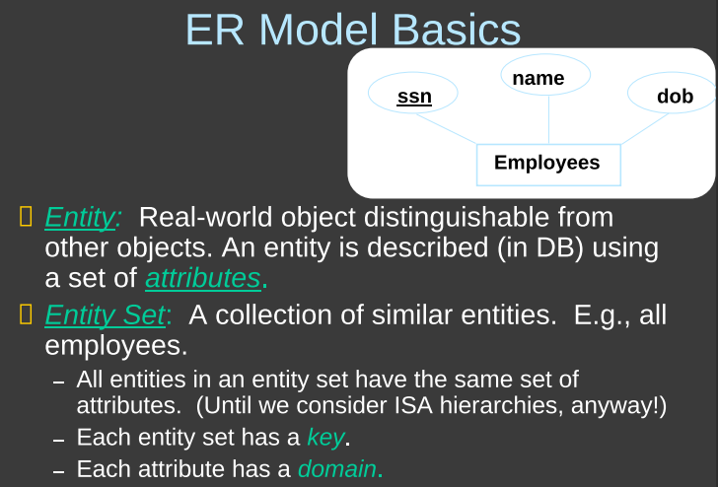
Entity: an object of the real world that we want to model (a person, a job…) we describe entity by the attributes attached to it. An entity is a single individual (one student) but when we design a dataset we do not talk about a single student. In the design I talk about a group of entities.

Entity set: is a collection of similar entities (like objects that share the same attributes). [when we draw we use a rectangle representing an entity set]. Since they are all entities of the same type they share some attributes. Every employee has three attributes, a name, a parking lot, ssn = social security number. My database should collect 3 attributes. Two other important elements are key and domain
- Key of an entity set: one or more attributes that you choose that uniquely identify the entity is the entity set. A good one is the ssn (there can not be two employees with the same ssn number). It is a way to identify the entity. Nobody will tell you what is the right key. If you can not distinguish two entities is an issue. All entities set must have a key. In a preliminary phase you can avoid choosing a key but later you will need to choose one. A key can be a set of attributes, like name + surname (there could be more people with same name or same surname, but is not very likely to have two people with same name and surname).
- Domain of an entity set: is the type of attribute (name is a string, ssn is a string), it adds additional structure to the data.

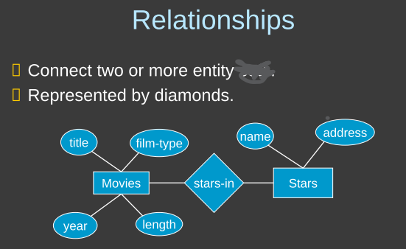

Relationship: connect two or more entities (NOT ENTITY SET).

All these possible relationships are a relationship set.

Entities are single elements, entity set is a group of entities. A relationship is just a connection (the arrow) [the relationship set are represented by diamonds]

All movies should have 4 attributes
- title
- kind of movie
- year
- length in minutes

Stars (actors) have 2 attributes
- name
- address

Note: no defined relationship direction.

In the database it is possible that a movie
- has no actor at all (like lion king)
- A movie with a single actor
- A movie with multiple actors

In the dataset it is possible that an actor
- Is not acting in any movie (just started career)
- Acted in a movie
- Acted in multiples movies

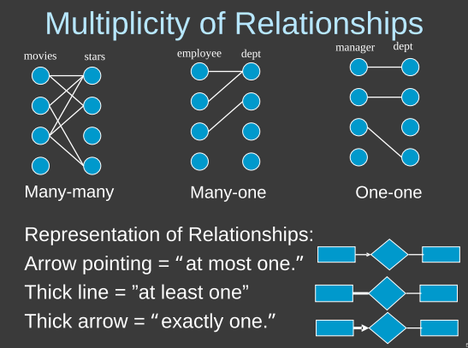
Many movies can be connected to many actors and vice versa

Many-one: many employees can be connected to a single department. But you can not do the other direction
One-many: opposite direction, one department can have many employees, but one employee can not be in different department
One-one: one manager can only have one department, and one department can only have one manager.

Note: the representation of relationship is divided in two parts: movies to stars and also stars to movies.

Actor → stars in ⇐ movies

Symbols:
- No defined relationship, can be at least one, at most one, exactly one
→ at most one
- at least one
⟹ exactly one

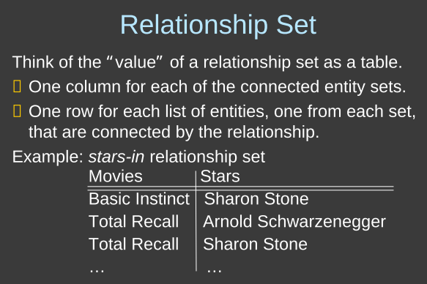
You put in the table all the relations that could occur.

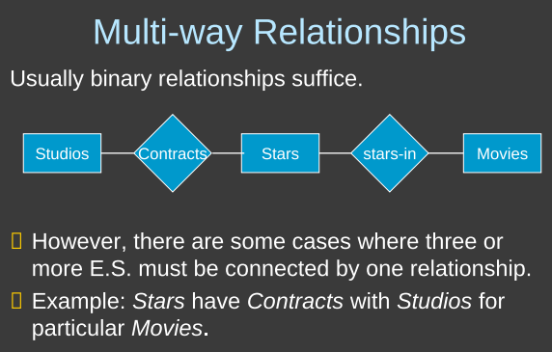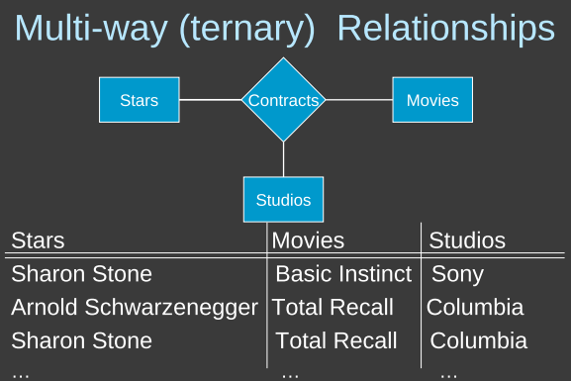
Connect more than two entities.

Schwarzenegger had a contract with Universal Studio, but for which movie? We want to evolve three different entities (actor, movie and studio)

Use a ternary (or others) relationship: each row represents one relation that an actor has with a movie and a studio. Three elements represent a single contract. Each relationship is determined by the entity involved in it. I can not have the same row again. It is like a relationship has a key.

⟹ we could have a contract of an actor for a movie but with two different studios. This could happen.

If we have it means that an actor (star) can be associated with one and only one pair of movie and studio.
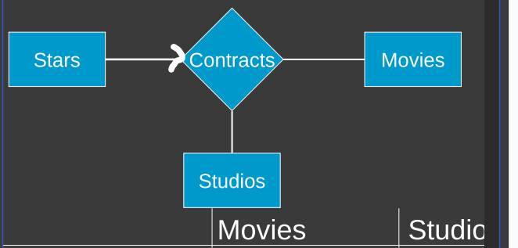

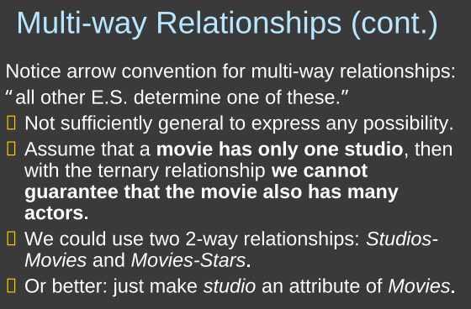

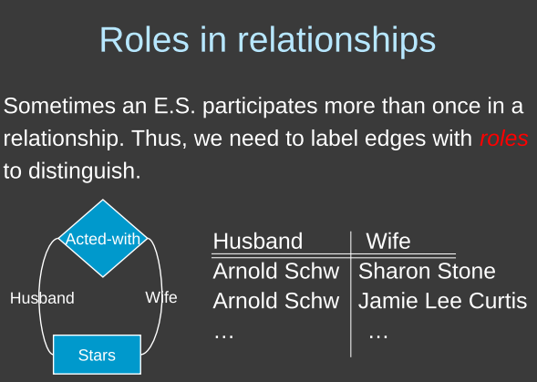
Sometimes you want to specify the role. You want to specify who played the husband and who the wife.

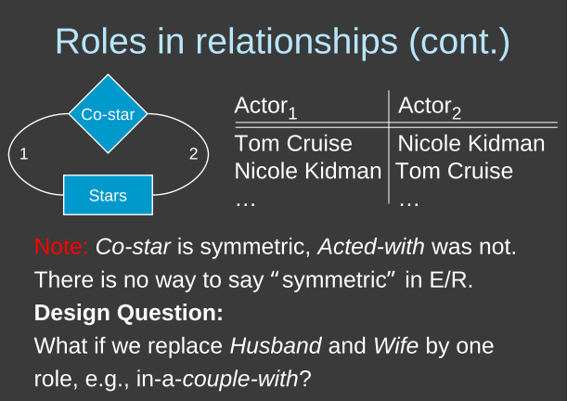
specify that two actors were co-star, there is a precise order.

Note: there are things we can not design.

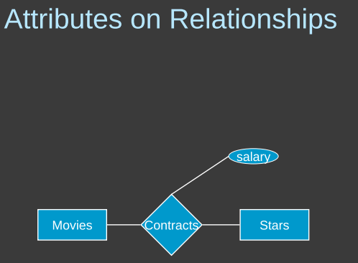
contract between movie and star (we do not care now about the studio).
- If I put the salary on the actor it means that the salary is a property of an actor, and so it does not depends on the movie
- If we add salary to the movie it means that all the people took the same salary in the movie.
We want some attributes of the relationship itself, the salary is not specific to the movie or to the actor, it is specific to the contract. So we add the attribute to contracts.

When we want to add an attribute to a relationship we can do it. There are cases in which a value is specific to a relationship and not to an entity set

The issue is that here the salary will be fixed.

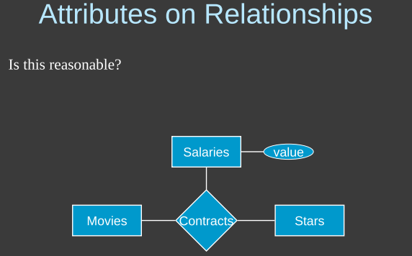
Instead of using an attribute we could use an entity set that has a single attribute (a value). This is not reasonable because the entity set has only an attribute that is not able to identify uniquely. Also we complicate the project and we change the meaning of the diagram.

Before we say that there are only two entities participating, but with salary as an entity set we change it.

Contract is not anymore between movies and stare but it is between movies, stars and salaries. We have three elements that uniquely identify a contract now. Also now I could have
Titanic, Di Caprio, 4000 and Titanic, Di Caprio 2000 and both at the same time are valid 🙁

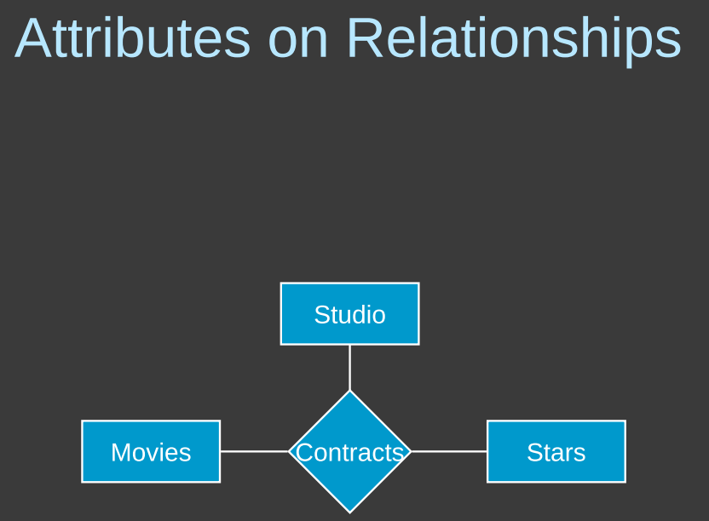
Here the contract is identified by the movie, the actor and the studio. This means that I can have two relationship like
Titanic, Di Caprio, Sony and Titanic, Di Caprio, Columbia but do we really need this kind of relationship? NO

It is possible to encode multi-way relationship with only binary relationship is to encode the contract relationship as an entity set

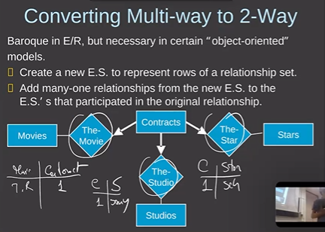
We give more importance to the contract. But one contract now should mention precisely one movie and princely one studio and precisely one actor.

Now a contract has exactly one movie, exactly one actor and exactly one studio.

We need a key to connect contracts to movies, another to connect contracts to stars and another to connect contracts to studios.

If we always use the same key we can represent the triple.

Now the contract must have some key (because it is an entity set).

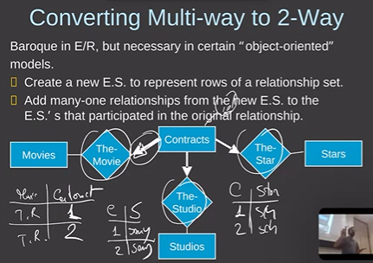
But now we need a way in the diagram that the key is made of the connected entity keys.

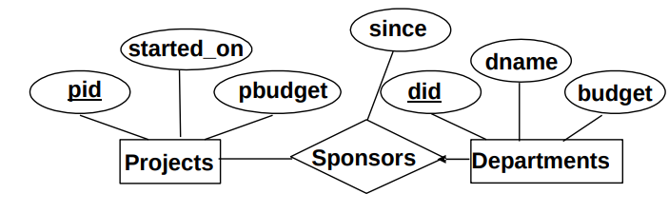
Here we have that a department can pay for no project or one project (simple arrow: at most). On the other side we have that a project can be paid by no departments, one department or multiple departments.

Now we want to add that whenever a department sponsors a project there must be some employee of the department that is elected as supervisor of the payment. We want to also keep track of the employee that is supervising the payment.

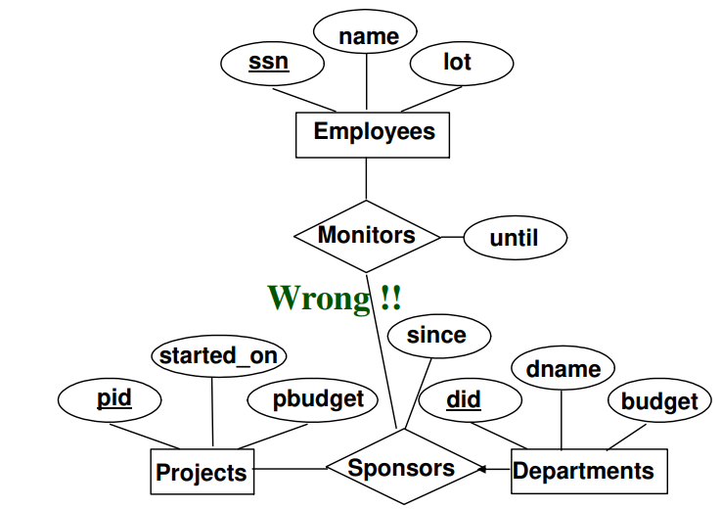

Remember: when you increase the number of entities participating in a relationship it means that the relationship is stronger.

Also you store many informations ⟹ exponential 🙁

To avoid this we can use aggregation.

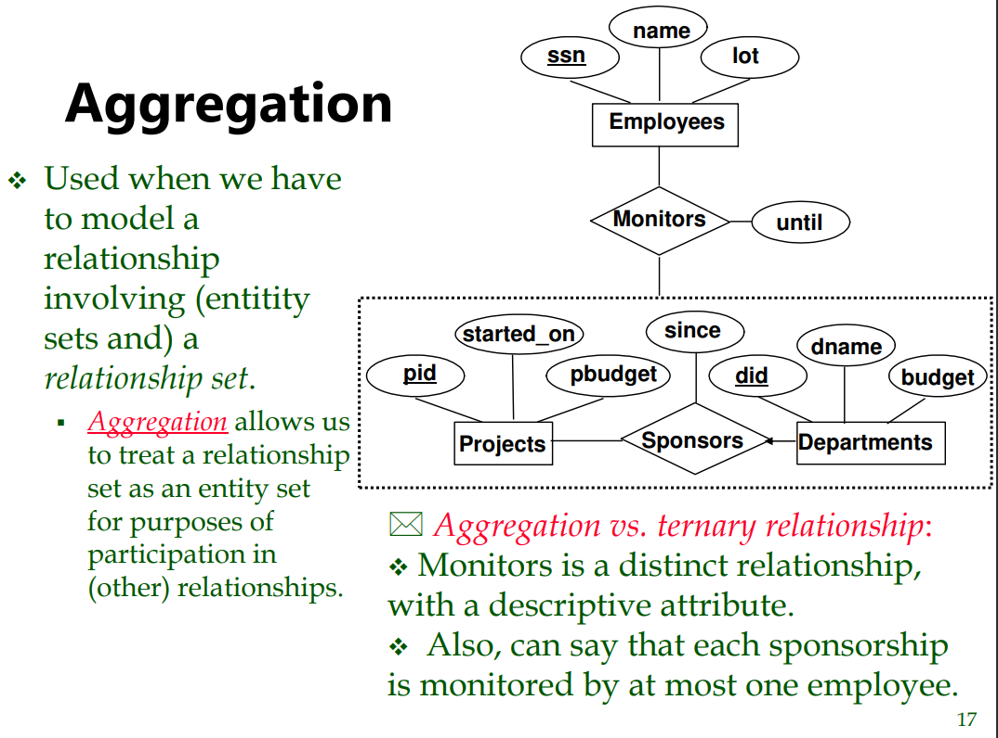
Aggregation connects an entity set to a relationship set. It temporary elects a relationship in an entity set, we group the relationship together with all the entities that participates in a big rectangle that we consider an entity set (only for that relation with employees for example)

